# A

Practical File On

**Advance Java Lab**

**INFORMATION TECHNOLOGY**



**ENGINEERING COLLAGE BIKANER**

# Affiliated to

**BIKANER TEHCNICAL UNIVERSITY, Bikaner**

**Submitted to: Submitted by:**

# Dr. Rahul Agarwal Name: Praveen Jakhar

Branch:IT

Roll no: 20EEBIT019

**INDEX**

|  |  |  |  |
| --- | --- | --- | --- |
| s.no. | Description | Date | sign |
| 1 | write a java program to print hello world |  |  |
| 2 | write a java program to print prime number |  |  |
| 3 | Write a java program to print Fibonacci number |  |  |
| 4 | Write a java program to print palindrome number |  |  |
| 5 | write a java program for checkbox |  |  |
| 6 | write a java program for list |  |  |
| 7 | write a java program for simple button |  |  |
| 8 | write a java program for radio button |  |  |
| 9 | write a java program for calculator |  |  |

# **Program 1**:- Write a java programme to print hello world

Ans:class HelloWorld

{

public static void main(String args[])

{

System.out.println("Hello, World");

}

}

Output :Hello, World

# **Program 2**:-Write a java programme to print prime number Ans:-

public class PrintPrimeNumbers1 { public static void main(String[] args)

{ int i, number, count;

System.out.println(" Prime Numbers from 1 to 100 are : "); for(number = 1; number <= 100; number++)

{

count = 0;

for (i = 2; i <= number/2; i++)

{

if(number % i == 0)

{

count++; break;

} }

if(count == 0 && number != 1 )

{

}

}

Output:-

System.out.print(number + " ");

}

}

2 3 5 7 11 17 19 23 29 31 37 41 43 47 53 59 61 67 71 73 79 83 89 97

**Program 3**:-Write a java program to print Fibonacci series Ans:-

class main {

// Function to print the fibonacci series static int fib(int n)

{

// Base Case

if (n <= 1) return n;

// Recursive call return fib(n - 1)

+ fib(n - 2);

}

// Driver Code public static void main(String args[])

{

// Given Number N int N = 10;

// Print the first N numbers for (int i = 0; i < N; i++) {

System.out.print(fib(i) + " ");

}

}

}

Output:-

0 1 1 2 3 5 8 13 21 34

# **Program 4:**- Write a java program to print Palindrome number Ans:-

class Main {

public static void main(String[] args) { int num

= 3443, reversedNum = 0, remainder; // store the number to originalNum int originalNum = num;

// get the reverse of originalNum // store it in variable while (num != 0) {

remainder = num % 10; reversedNum = reversedNum * 10 + remainder; num /= 10;

}

// check if reversedNum and originalNum are equal if (originalNum == reversedNum) { System.out.println(originalNum + " is Palindrome.");

}

else

{

System.out.println(originalNum + " is not Palindrome.");

}

}

}

Output :3443 is Palindrome.

# **Program 5**:- Write a java program for checkbox.

Ans:**import** javax.swing.*;

**public class** CheckBoxExample

{

CheckBoxExample(){

JFrame f= **new** JFrame("CheckBox Example"); JCheckBox checkBox1 = **new** JCheckBox("C++"); checkBox1.setBounds(100,100, 50,50);

JCheckBox checkBox2 = **new** JCheckBox("Java", **true**); checkBox2.setBounds(100,150, 50,50); f.add(checkBox1);

f.add(checkBox2); f.setSize(400,400); f.setLayout(**null**); f.setVisible(**true**);

}

**public static void** main(String args[])

{

**new** CheckBoxExample();

}}

Output:-

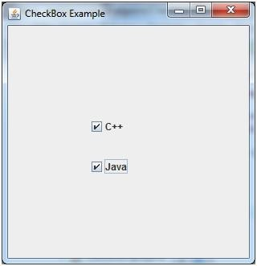

# **Program 6**:- Write a Java program for list Ans:-

**import** javax.swing.*;

**public class** ListExample

{

ListExample(){

JFrame f= **new** JFrame();

DefaultListModel<String> l1 = **new** DefaultListModel<>(); l1.addElement("Item1"); l1.addElement("Item2"); l1.addElement("Item3"); l1.addElement("Item4");

JList<String> list = **new** JList<>(l1); list.setBounds(100,100, 75,75); f.add(list); f.setSize(400,400);

f.setLayout(**null**); f.setVisible(**true**);

}

**public static void** main(String args[])

{ **new** ListExample(); }} Ouput:-

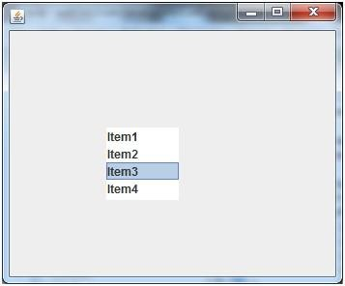

Program 7:- Write a java Program for simple button Ans:**import** javax.swing.*; **public class** ButtonExample { **public static void** main(String[] args) { JFrame f=**new** JFrame("Button Example");

JButton b=**new** JButton("Click Here"); b.setBounds(50,100,95,30);

f.add(b); f.setSize(400,400); f.setLayout(**null**); f.setVisible(**true**);

}

}

Output:-

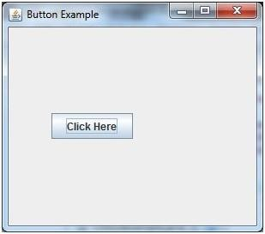

# **Program 8:**- Write a java programme for radio button Ans:-

**import** javax.swing.*;

**public class** RadioButtonExample { JFrame f;

RadioButtonExample(){ f=**new** JFrame();

JRadioButton r1=**new** JRadioButton("A) Male"); JRadioButton r2=**new** JRadioButton("B) Female"); r1.setBounds(75,50,100,30); r2.setBounds(75,100,100,30); ButtonGroup bg=**new** ButtonGroup(); bg.add(r1);bg.add(r2); f.add(r1);f.add(r2);

f.setSize(300,300); f.setLayout(**null**); f.setVisible(**true**);

}

**public static void** main(String[] args) {

**new** RadioButtonExample();

}

}

Output:-

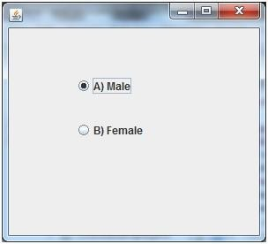

# **Program 9**:- Write a java program for calculator Ans:-

import java.util.Scanner;

class Main {

public static void main(String[] args) {

char operator;

Double number1, number2, result;

// create an object of Scanner class Scanner input = new Scanner(System.in);

// ask users to enter operator System.out.println("Choose an operator: +, -, *, or /"); operator = input.next().charAt(0);

// ask users to enter numbers System.out.println("Enter first number"); number1 = input.nextDouble();

System.out.println("Enter second number"); number2 = input.nextDouble(); switch (operator) {

// performs addition between numbers case '+':

result = number1 + number2;

System.out.println(number1 + " + " + number2 + " = " + result); break;

// performs subtraction between numbers case '-':

result = number1 - number2;

System.out.println(number1 + " - " + number2 + " = " + result); break;

// performs multiplication between numbers case '*':

result = number1 * number2;

System.out.println(number1 + " * " + number2 + " = " + result); break;

// performs division between numbers case '/':

result = number1 / number2;

System.out.println(number1 + " / " + number2 + " = " + result); break;

default:

System.out.println("Invalid operator!"); break;

}

input.close();

}

}

# Output:-

Choose an operator: +,-,*,or /

*

Enter First nmber 3

Enter second number 9

3.0*9.0=27.